

GLOBODIET
How to install/uninstall GloboDiet application

Draft
Dietary Exposure Assessment Group (DEX)
International Agency for Research on Cancer

GloboDiet Application Requirements

The minimum system requirements to run the GloboDiet application or the GloboDiet Data entry application are a PC with:

- Intel or compatible Pentium III
- Windows XP service pack 2 or higher
- Minimum of 512 Mo of Ram
- 600 MB of available hard disk space
- 15” screen with a resolution of 1024x768 or higher

GloboDiet Application Installation

Uninstall the previous GloboDiet application version
Important
Installing/uninstalling the GloboDiet application requires that you have the administrator rights for the PC. A warning pop-up will appear if you don’t have the administrator rights.

If any previous version installed on the machine:

- Uninstall GLOBODIET application by running Uninstaller.bat program.
- See point “How to uninstall the GloboDiet Application” (page 16)

Now you are ready to install the new GLOBODIET SETUP.

GloboDiet application Installation
Important
Installing the GloboDiet application requires an account with administrator rights
Extract all the files available in GloboDiet_SetupPackagexxxx.Zip using “SubFolder information” option.
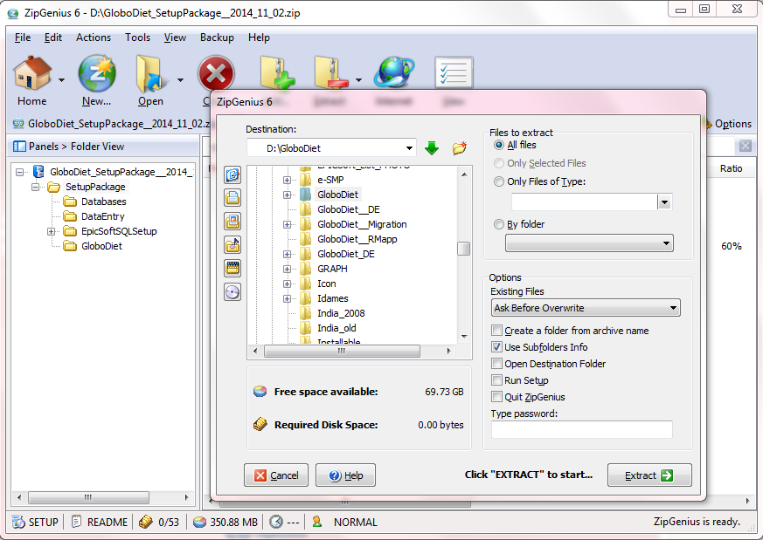
Right-click on Setup.bat file in the folder where the GloboDiet Setup is located and select the function “Run as administrator” to start the installation:
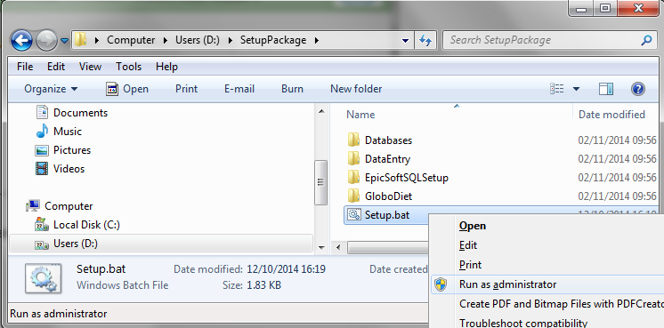
Figure 1 – By clicking on the right mouse button, select the function “run as administrator” to start installation

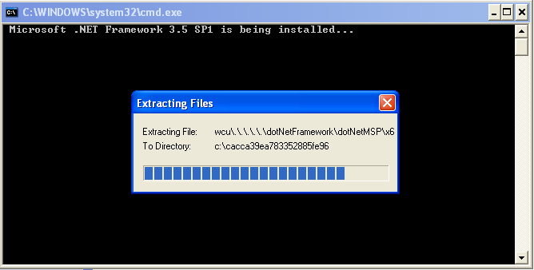
Figure 2 – Files of .NET framework 3.5 Sp1 are automatically extracted

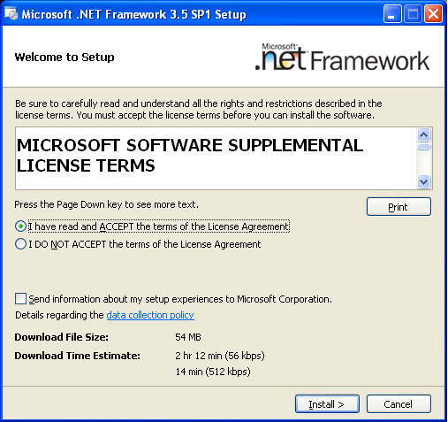
Figure 3 – Accept the license agreement from Microsoft Corporation and click on “Install”

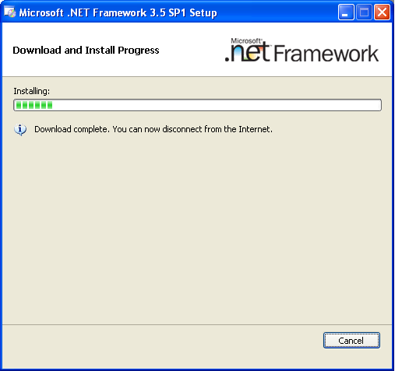

Figure 4 –First .NET framework 3.5 sp1 is installed automatically
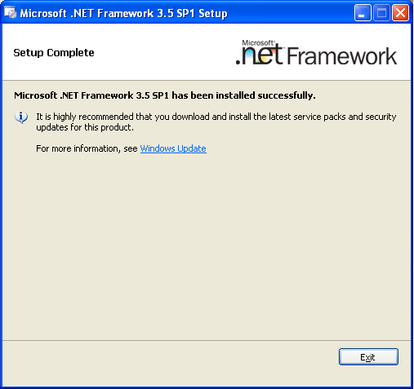

Figure 5 – Once .NET framework 3.5 sp1 installation is completed, click on “Exit”

By default, the setup program will check whether any related applications have alreadybeen installed.
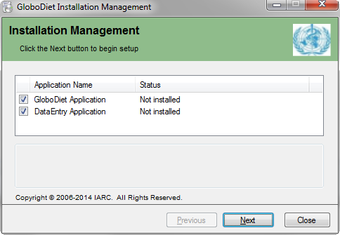
Figure 6 – Choose the application(s) which you want to install and then click on “Next”
A screen (Figure 7) is displayed listing all the pre-requisites needed to be installed before the actual SQL Express 2008 installation begins. Click on the “Next” button to install programs not already installed.
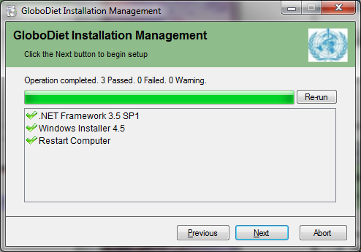
Figure 7 – List of pre- requisites and their installation status on the PC (e.g. here, all the pre-requisites are in check so can proceed by clicking on “Next”).

Click the “Next” button to install programs not already installed (here Windows Installer 4.5).
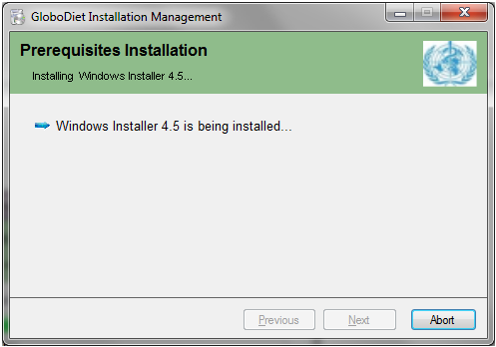

Figure 8 – Windows Installer 4.5 is being installed.

Then it may be necessary to restart your computer if any of the pre-requisites need to be installed. In such case, click on the “Yes” button the restart immediately (see figure 9 below). Otherwise, if you choose the “NO” button, you have to reboot your computer manually and won’t be able to continue the installation procedure; the “Abort” button will need to be activated.

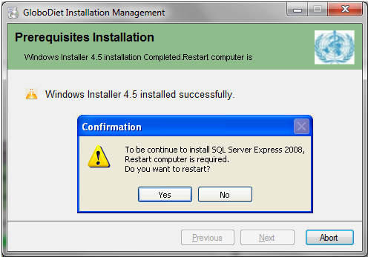
Figure 9 – Restarting the computer is required if you get this pop-up.

In case you choose “No”. If you exit the setup program and re-run it (setup.bat program), you will see a screen as given in Figure 10 indicating a necessary restart (rebooting). You need to reboot to be able to go on with the installation.
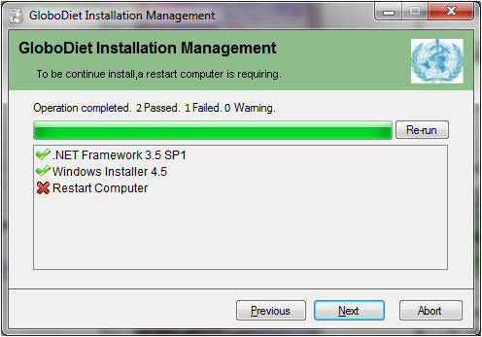

Figure 10 – A necessary reboot is indicated.

Once the restart (rebooting) is done, click on “Next” to continue with the installation (Figure 11).

Figure 11– Click on the “Next” button to continue with the installation.

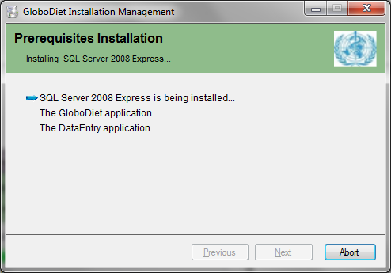
Figure 12 – SQL Server 2008 Express will be installed first.
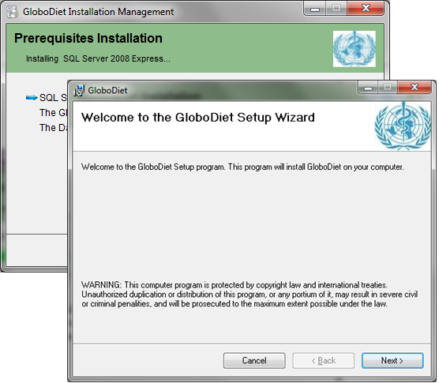

- Once the installation of SQL Server 2008 is completed, the progress of installation continues with the GloboDiet application(s) selected before (GloboDiet and/or DataEntry).
Figure 13 – The GloboDiet application(s) will be then installedone by one by selecting the “Next” button

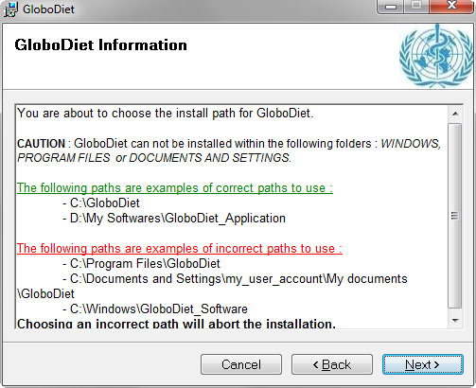
Figure 14 – A warning message is displayed, please read carefully and continue by selecting the “Next” button
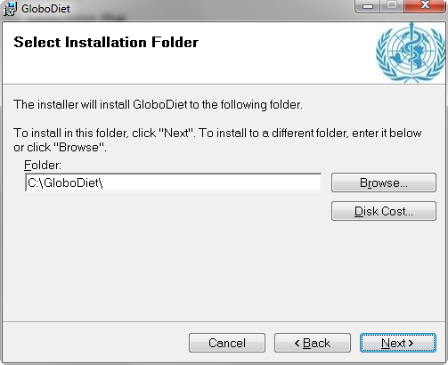
Figure 15 – Select a path(directory\folder) to install the application. By default, the set-up will propose C:\GloboDiet directory, but you can modify it by using the “Browse” button and by selecting the preferred directory available on your PC; continue by selecting the “Next” button.

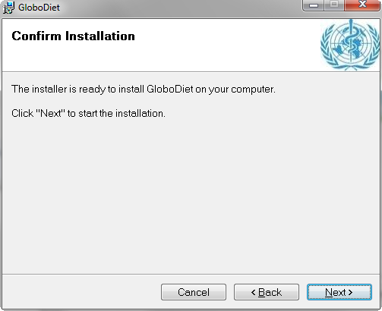
Figure 16 – Continue by selecting the “Next” button.

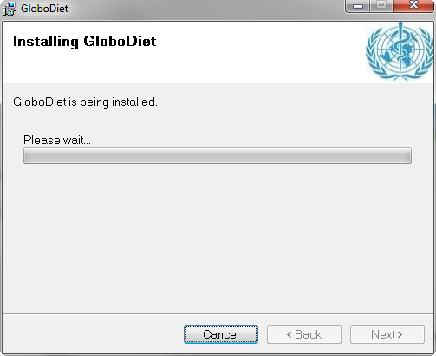
Figure 17 – GloboDiet is now being installed, which may take a few minutes

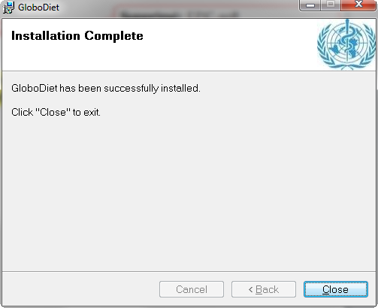
Figure 18 – Once the “GloboDiet Installation Complete” window is displayed, the GloboDiet installation is finished and you then click on the “Close” button.
- If you have selected both GloboDiet and Data Entry applications in figure 6, the screens from figure 14 to figure 19 will be proposed/displayed again but for the Data Entry application
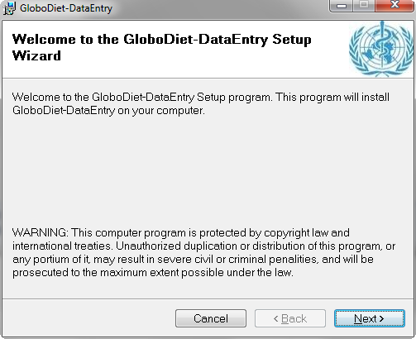 etc…

Once all the prerequisite components and the applications are installed, click on “Next” to proceed to the configuration step (see figure 19 below)
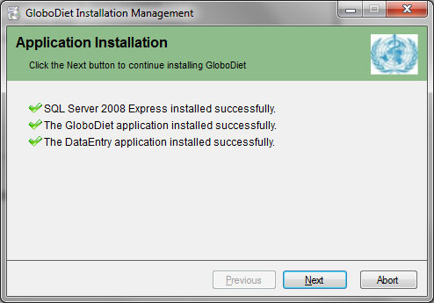
Figure 19 – All the components and the application are installed successfully
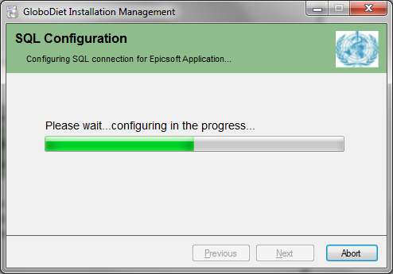
Figure 20 – A pop-up window will appear informing that configuration of the application is in progress (no further action regarding this step is necessary)

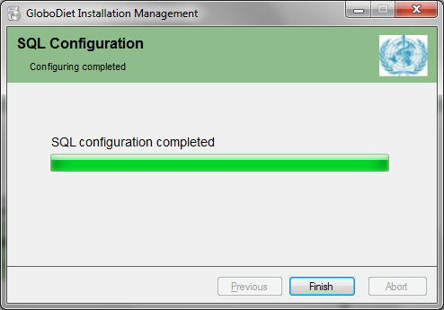
Figure 21 – Once the configuration of the application completes,. you can exit by selecting the “Finish” button.
Remark: In case SQL Server 2005 or newer was already installed on your computer and SQL authentication mode was set to ‘Windows Authentication’ then during configuration the setup program will switch this mode to “Mixed” mode automatically (Figure 23).Click on “Yes” to restart SQL and continue.
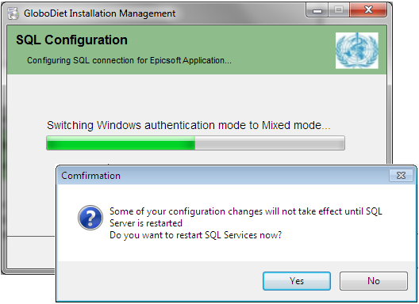
Figure 23 – The setup program is switching from Windows Authentication mode to Mixed mode
- Once all the steps above have been completed you will find on your desktop one or both of the following icons (depending on the applications you selected to install). You can double-click on the icons to launch GloboDiet or GloboDiet Data Entry applications.
 OR 
- When you run the GloboDiet program on your computer for the first time you have to run it in administrator mode. All the related databases will be installed and a series of messages will be popping up (no confirmation needed here) See below for examples.
Installing GloboDiet database
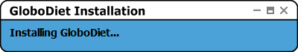
Installing Interview database
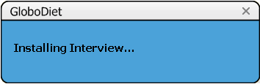
- If everything has been installed correctly, the main screen of GloboDiet application is displayed (and GloboDiet is ready for use):
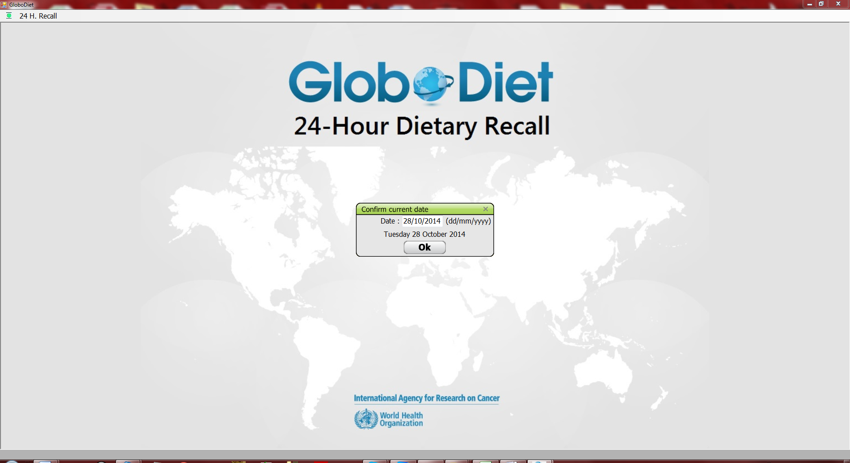
- In the unexpected event that the software encounters a problem in the process of installing the databases, the following error message is displayed:
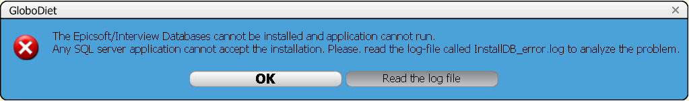
You may read the log file to get more information about the problem and inform your IT help-desk.
GloboDiet Application: How to uninstall
Important
Installing the GloboDiet application requires an account with administrator rights

- In the GloboDiet directory (e.g. C:\GloboDiet), run the program called Uninstaller.bat.

Figure 1: A warning window is displayed; answer ‘Yes’ twice: to continue with uninstalling and then to allow changes to take place:
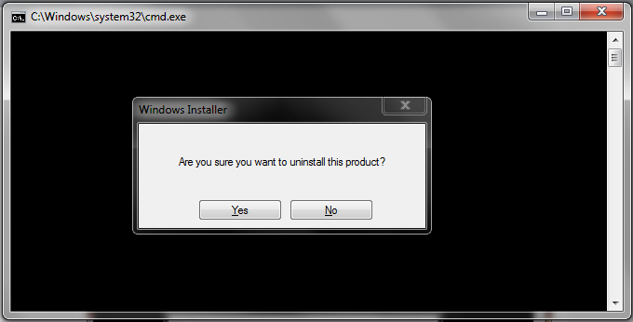
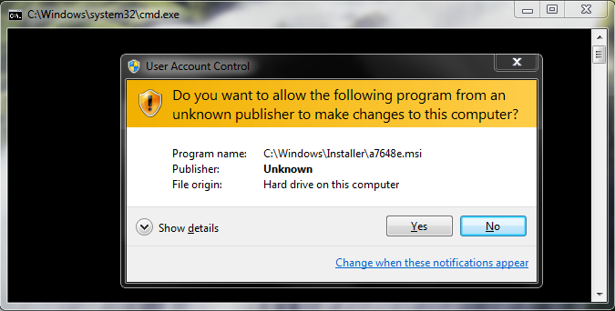

Figure 2: The next step may take a few minutes:
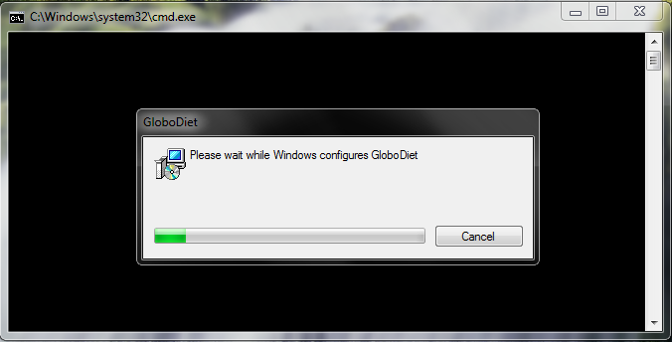

A question to delete databases used by GloboDiet is displayed.
- These 2 databases are called:
  - ‘GloboDiet’ or formerly ‘EpicSoft’ containing the parameter data (e.g. food list, recipe list…)
  - ‘Interview’ databases containing all the collected interviews
- You can select several databases to remove but if you aren’t sure don’t remove them.
Example:
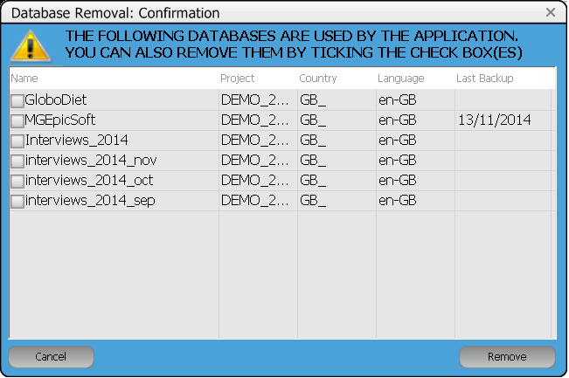

- After a few more seconds the un-installation is completed.

